THIRD SEMESTER PROJECT

Online Aptitude Test -
Developer Guide

Date of Submission: 02-NOV-2023

Submitted By:

Student NameIDAbdul Rehman Siddiqui1336545Balaj Ahmed Khan1335831Ashhad Khan1335849Muhammad Rameez1336479

Add Category

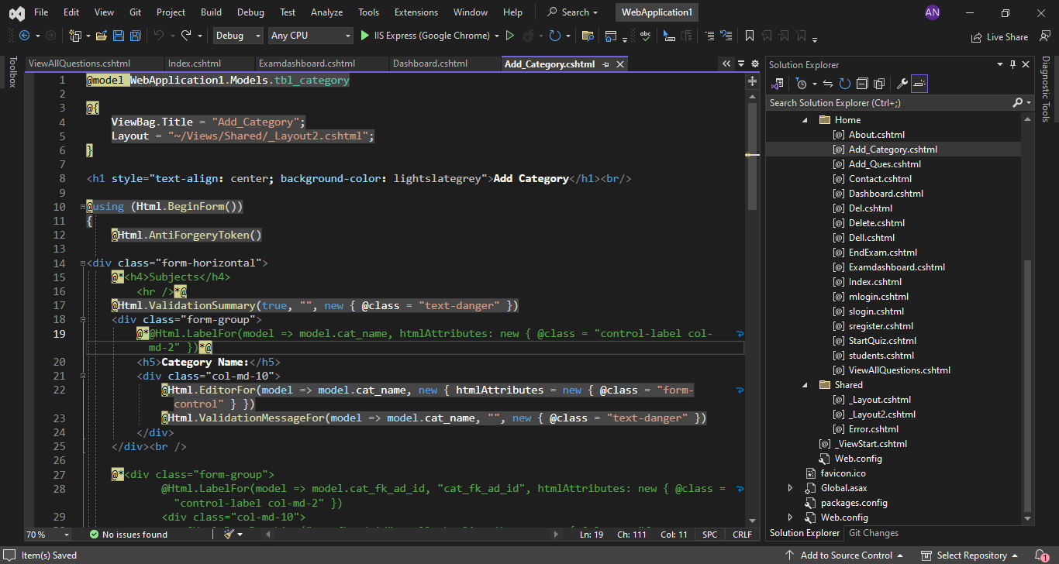

Add Question

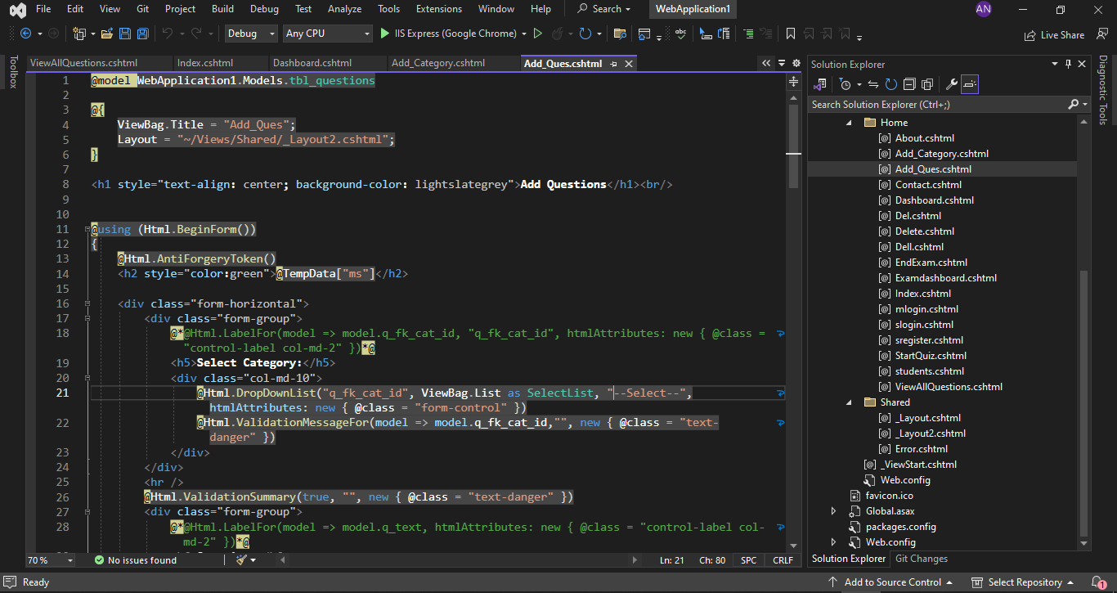
Admin Login

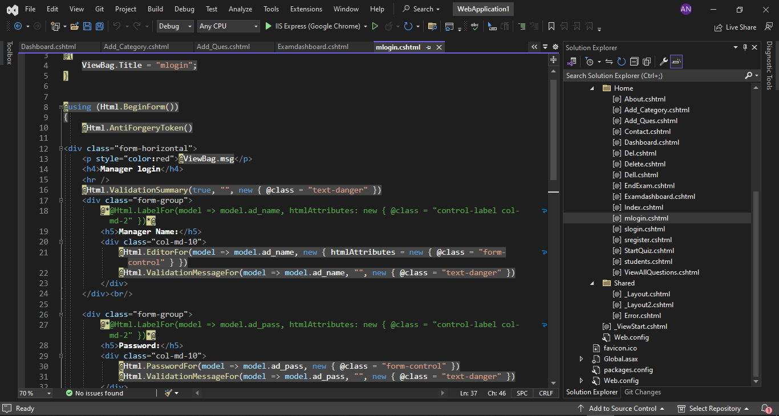

Exam Dashboard

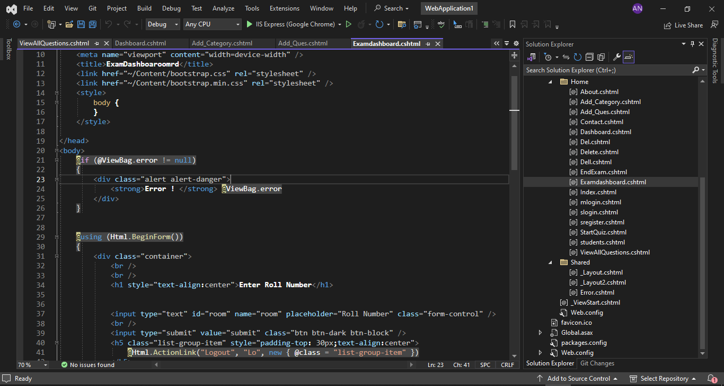

Index

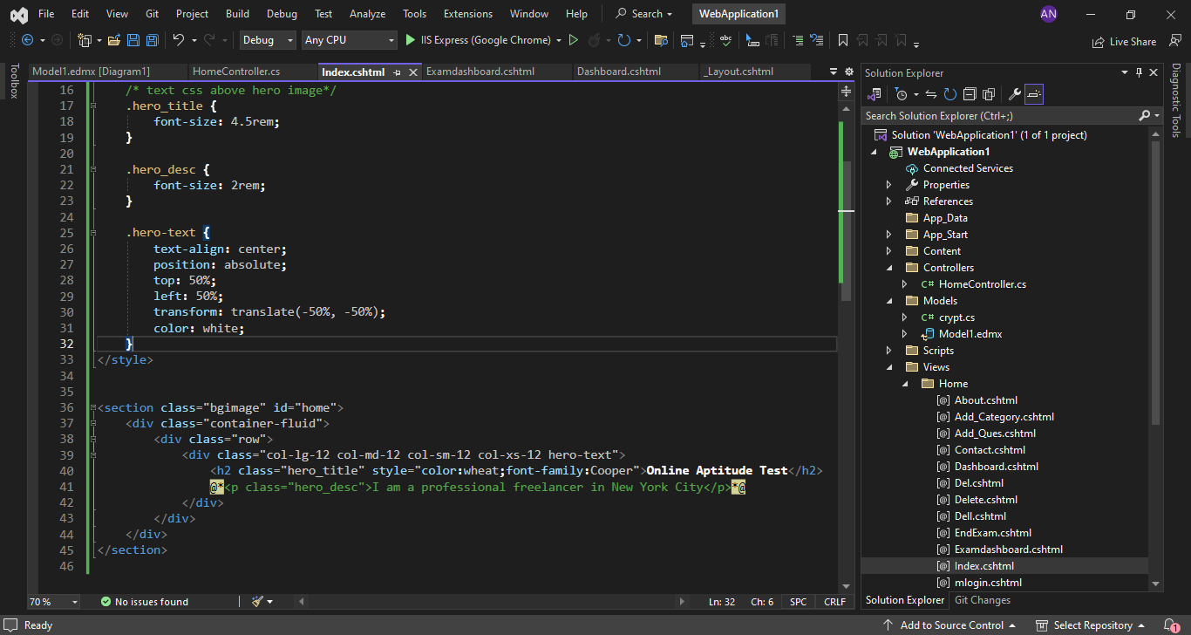

Student Login

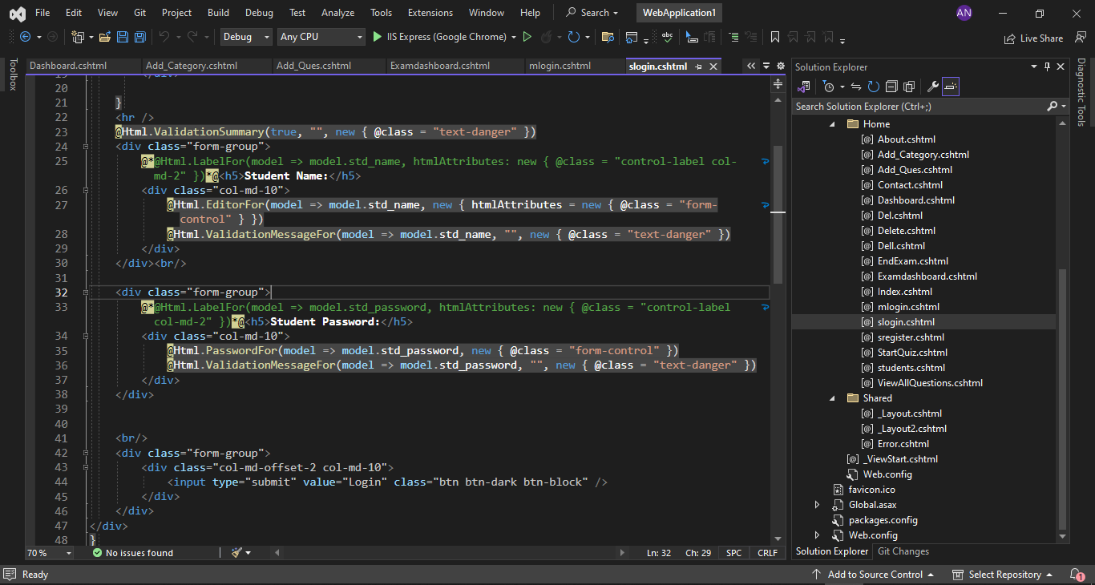

Student Registration

